Project – 1

Caesar & Hill Cipher

*************************************************************************************

**Instructions**: Please use Python as the language. Please do not use online code. If I see the code is not original ZERO will be awarded.

**Deliverable:** You will submit a writing report and do a class presentation/demo of the project.

**Submission**: Group

**Due date**: September 21, 2023. During class time with presentation.

*************************************************************************************

Internally, computers store keyboard characters (capital and small letters, punctuation marks, space, digits, symbols, and so on) and others (like Enter, or Command-Z, or Shift-Ctrl A) as numbers—binary sequences. The computer industry standard numbering is called Unicode. For most purposes, even programmers and web developers do not need to know what number represents what character, but sometimes we do need to specify a character by its number. This table shows the Unicode for some of the keyboard characters.

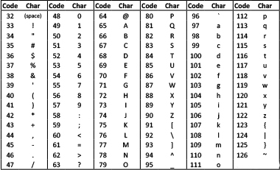

**Task:** Using Caesar cypher shift 5, encrypt and decrypt the following text.

*On 10 May 1940, Winston Churchill became Prime Minister of the United Kingdom*

In this project, you have to use Hill Cipher to encrypt a message and then decrypt the message. The message is:

“*Success is the ability to go from one failure to another with no loss of enthusiasm*”

In the process use square matrices of different sizes. At use three such variation:

1. 3 x 3
2. 4 x 4
3. 5 x 5